ANALYSIS STRATEGIC NICHE MANAGEMENT (SNM)
Rob Raven, Eindhoven University of Technology, August 2012

Introduction
Below is a description of a simple Strategic Niche Management (SNM) analysis that can be applied to innovative sustainability-projects. The analysis may help you to identify chances and hindrances that the project could meet. It can be the basis for adapting your project in order to increase its potential to contribute to system innovation for sustainability.
In the description it is presupposed that you perform the analysis with others who are involved in the project.
The analysis was developed within the framework of the Pioneers into Practice project that is part of the wider European Climate-KIC programme (www.Climate-KIC.org).
For more information on the Strategic Niche Mangement approach see: Van den Bosch, S. and J. Rotmans (2008). Deepening, Broadening and Scaling up. A Framework for Steering Transition Experiments. Knowledge Centre for Sustainable System. Innovations and Transitions (KCT), publication no 2. The publication can be downloaded from www.transitionsinpractice.nl

START

1. Define the niche project or experiment that you want to analyze from a SNM perspective
Describe briefly: what is the niche-project about? See for an explanation of the concept of a niche project, or transition experiment as it is sometimes called, table 1 below and figure 1.

Table 1 Niche projects (‘transitions-experiments’) compared to classical innovation projects
 | Classical innovation project | Innovative niche project (transition-experiment)
Goal | Developing potential solutions to practical problems and/or developing new markets | Contributing to societal challenges, such as sustainable development or a low carbon economy
Nature and ambition of the innovation | Smaller innovations and adaptations of existing processes of products. These innovations don’t need major changes in existing practices, organisation, culture, or financial or juridical arrangements (the ‘regime’). | The innovation(goal) is radical and involves major changes in existing practices, organisation, culture or financial or juridical arrangements (the ‘regime’).
Time horizon | 2-5 year | Beyond the specific niche-project; middle and long term.
Figure 1: ‘Niche (projects) explained
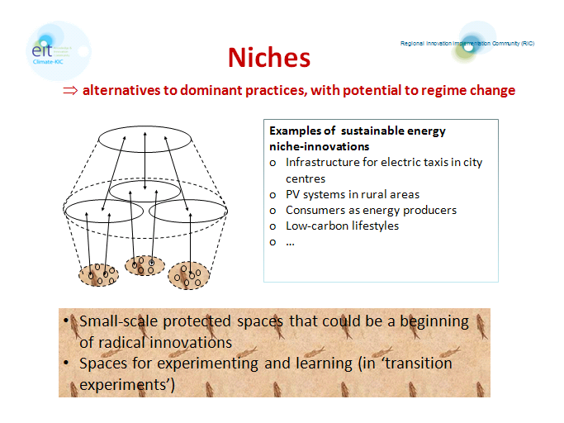

VISION

2. Answer the next questions about the vision involved and score. Collect your scores in the table below
- Does a leading long- or medium-term vision exist?
In case of a score of more than 1, continue with the following questions:
- How innovative or different is the vision from business as usual? (1: almost business as usual; 10 quite different from business as usual?)
- Do you consider the vision to be an attractive vision, easy to convey? (1: no; 10 yes)
- Does the vision pay attention to non-technical aspects of the low-carbon innovation included (for example cultural, financial aspects)? (no = 1; yes = 10).
- Is the vision spread and shared? (1= no; 10 yes, it is a vision that is shared by many, including major stakeholders. In case you need an example of possible stakeholders, see figure next question)

Vision/expectation aspects | Score
Is there a leading, long or medium-term vision?
How innovative is the vision?
Do you consider the vision attractive, easy to convey?
Are non-technical aspects included?
Is the vision spread and shared?
Total score/number of questions answered

ACTORS

3. Quickly determine: which are the relevant actors for your project and project ambition?
Jot down your results in the table below.

Actor group | Present in the niche-project network?  Yes or no?
Financial actors
Suppliers
Users
Producers
NGO’s
Public authorities
Relevant actors from the research network
Others, nl……….

4. Assess the quality of the social network around your project
Answer the questions below and score. Put down your scores in the table below.
- Do you think that important actors are missing? Score 1 if many important actors are missing; score 10 if all important actors are in the network.
- Are the actors involved able to provide the necessary resources? Score 1 in case of 100% no; 10 in case of 100% yes.
- Do you expect major resistance from any particular actor or social group and if so, do they have enough power to affect the project? Score 1 in case of resistance of powerful actors; 10 in case of no resistance.

Network quality aspects | Score
Are many important actors missing?
Are actors involved able to provide the necessary resources?
Is major resistance to be expected?
Total score/3

LANDSCAPE AND REGIME

5. What, in your case, are relevant landscape developments?
Determine major ‘landscape’ developments. Use figure 2 for an explanation of the ‘landscape’ concept. Which landscape developments support your project or can be made supportive and which not? Jot down your results in the table below.

Figure 2: the SNM ‘Landscape’
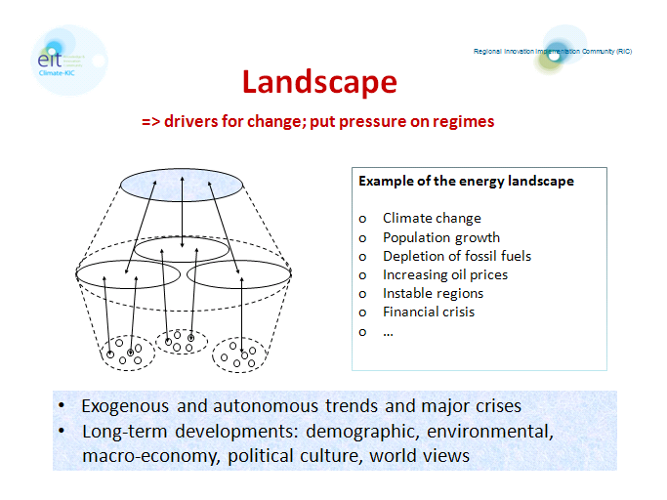

Landscape developments | Supportive, neutral or impeding?

6. What are the most relevant ’regimes ’for your niche project?
Use figure 3 for an explanation of the ’regime’ concept. Then determine the most relevant regime(s) for your project. One could for example think of the electricity regime; scientific regime; building/housing regime; etcetera. Do think about whether or how (much) your project (conditions) defer from the dominant regime.Low-carbon projects do often operate in more than one regime. Therefore, think about whether more than one regime is important for the project.
Note your results in the tables below.

Figure 3: The socio-technical regime
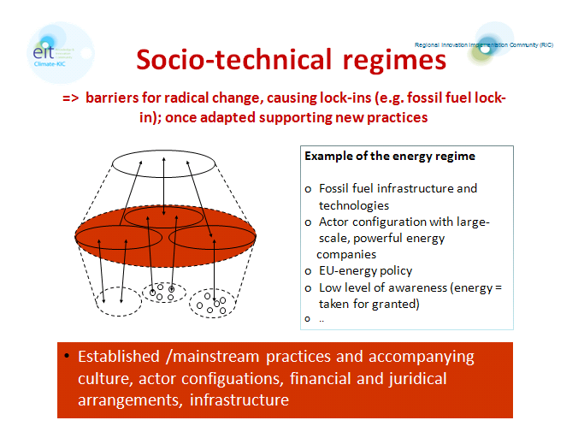

Regime 1: ……………………….. | Different from  mainstream: yes or no?
Cultural aspects (eg. norms on ambitions, expected behavior, scientific knowledge ), routines
Rules and regulations and for example financial arrangements
Infrastructure

Regime 2: ……………………….. | Different from  mainstream: yes or no?
Cultural aspects (eg. norms on ambitions, expected behavior, scientific knowledge ), routines
Rules and regulations and for example financial arrangements
Infrastructure

7. Given your answers to questions and 6 score in the table the opportunities that your project ambitions come through (1, no opportunities; 10, very likely regime breakthrough)?

Regime breakthrough | Score
Opportunities for regime breakthrough?

LEARNING

8. What could you learn about from your project and related innovative projects, given your ambitions and analysis of landscape and regime, that would be relevant to you or others involved. Think about lessons about technical aspects, cultural lessons, policy lessons, about markets, new financial arrangements, juridical conditions etc. Jot down your insights in the table below.

Aspects | In case of yes, you could probably specify
Technical
Cultural
About markets
About financial arrangements
Juridical conditions
..

9. What is the present quality of the learning process in this case (score 1-10)?
Answer the following questions and jot down your scores in the table below:
- Is a learning process organized about the project in its regime- and landscape context (e.g. workshops, lectures, publications)? Score 1 = no; score 10 is yes.
If yes: ask the following questions
- Are other actors involved? Score 1 = no; score 10 = yes, all relevant actors involved.
- Do you discuss from time to time if you are ‘doing the right things’ (reflective learning)? Score 1 = no; score 10 is regularly.

Learning aspects | Score
Is a learning process organized?
Are other actors involved?
Are you prepared for discussing from time to time whether you are doing the ‘right things’?
Total score/number of questions answered

SUMMARY AND ACTIONS

10. For a visual summary of your analysis, put the scores of questions 2, 4, 6 and 8 in the spider diagram on the next page and decide what your two favorite actions are.

Results of the Strategic Niche Management (SNM) analysis

Project title: ……………………………………….

SNM diagram

Action 1: what is your first action based on the SNM analysis?

Action 2: what is your second action based on the SNM analysis?

In cooperation with Bram Verhees of the Eindhoven University of Technology , Suzanne van den Bosch of Susi Consultancy and Lydia Sterrenberg, coordinator of the Pioneers into Practice mentoring programme.

